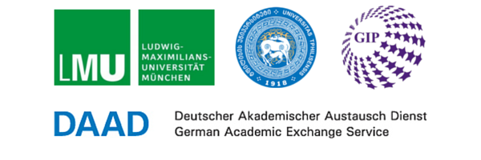
Autumn School
EU’s policies towards the East: Deepening, widening, bridging the gap?
Tbilisi, September 19-23, 2016

Preliminary Programme
Monday, September 19
9:00 to 10:30 Introduction, expectations, method and programme
10:30 to 11:00 Coffee break
11:00 to 12:30 The current situation in Georgia
12:30 to 14:00 Lunch Break
14:00 to 15:30 The European Union as a foreign policy actor
15:30 to 16:00 Coffee break
16:00 to 17:30 Russian domestic and foreign policy
Tuesday, September 20
09:15 to 10:30 The Eurasian Union from the perspective of Armenia
10:30 to 11:00 Coffee break
11:00 to 12:30 Workshop: relations between EU and EAU
12:30 to 14:00 Lunch Break
14:00 to 15:30 The Role of Media and Communication - Workshop I
15:30 to 16:00 Coffee break
16:00 to 17:30 The Role of Media and Communication - Workshop II
Wednesday, September 21
09:15 to 10:30 Basics for the development of future scenarios
10:30 to 11:00 Coffee break
11:00 to 12:30 Brainstorming for scenario development / division and focus of the working groups
12:30 to 14:00 Lunch break
14:00 to 15:30 Scenario development - Workshop I
15:30 to 16:00 Coffee break
16:00 to 17:30 Scenario development - Workshop II
Thursday, September 22
09:15 to 10:30 Scenario development - Workshop III
10:30 to 11:00 Coffee break
11:00 to 12:30 Scenario development - Workshop IV
12:30 to 14:00 Lunch break
14:00 to 15:30 scenario development - Workshop V
15:30 to 16:00 Coffee break
16:00 to 17:30 Completion of the final presentation
Friday, September 23
09:15 to 10:30 Presentation of future scenarios I
10:30 to 11:00 Coffee break
11:00 to 12:15 Presentation of future scenarios II
12:15 to 14:00 Lunch break
14:00 to 15:15 Presentation of future scenarios III
15:15 to 15:30 Coffee break
15:30 to 17:00 Evaluation and closing

This Autumn school is organized by Ludwig Maximilian University of Munich in partnership with Georgian institute of Politics and Tbilisi State University and supported by DAAD,

